How to install and setup of maven in Ubuntu server

Maven integration:-

1. Install maven integration plugin in jenkins.
2. Install maven packages on jenkins cli.
3. Specify maven path in “ global tool configuration”
4. Specify java path in the “global tool configuration”.

Step1:- install maven integration plugin in jenkins .

Go to jenkins – go to manage jenkins- go to plugins – click on available plugins – search maven integration and click on that finally install without restart.

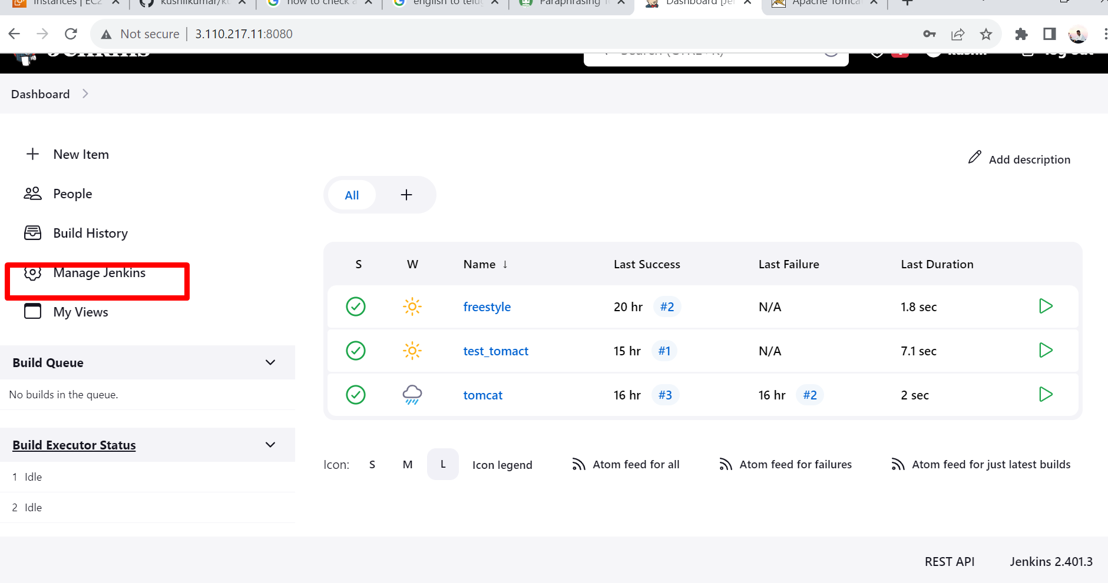

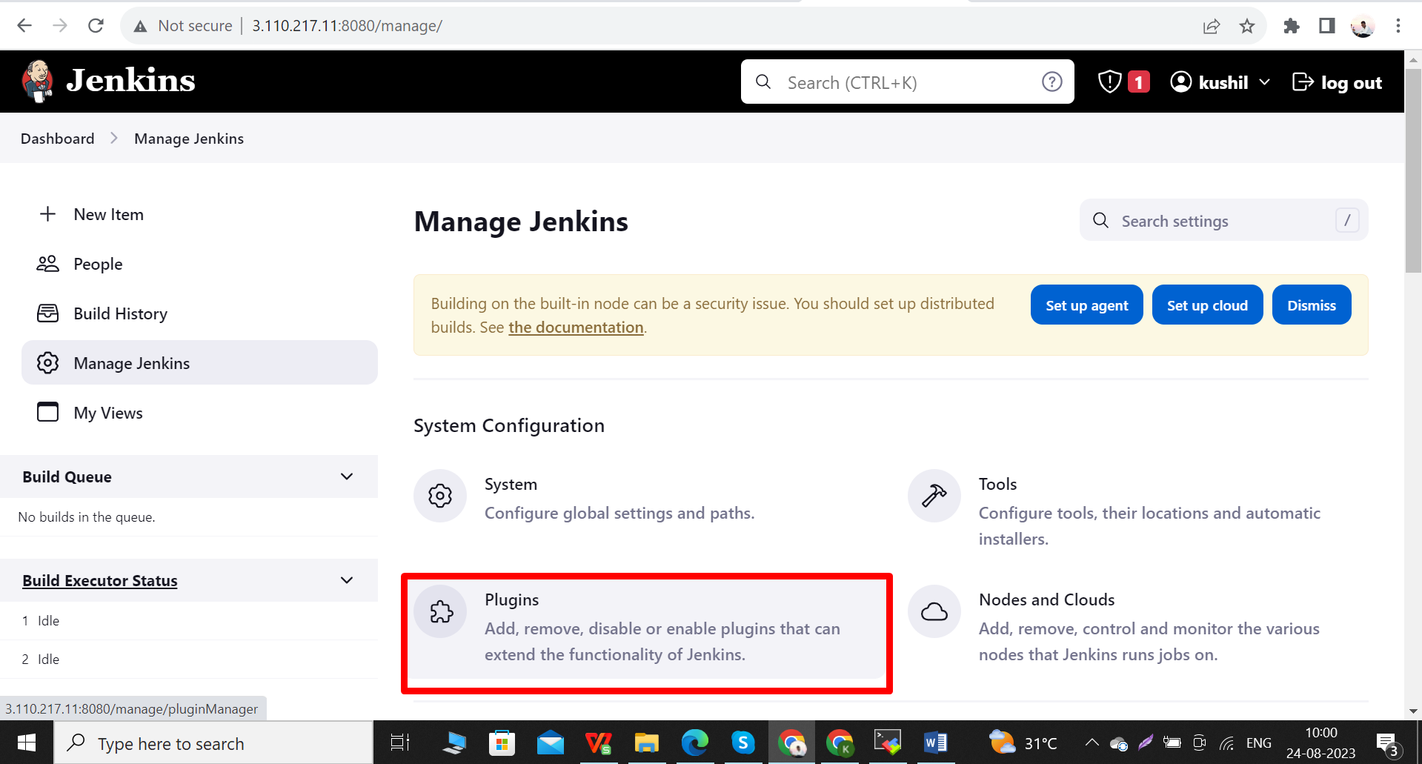

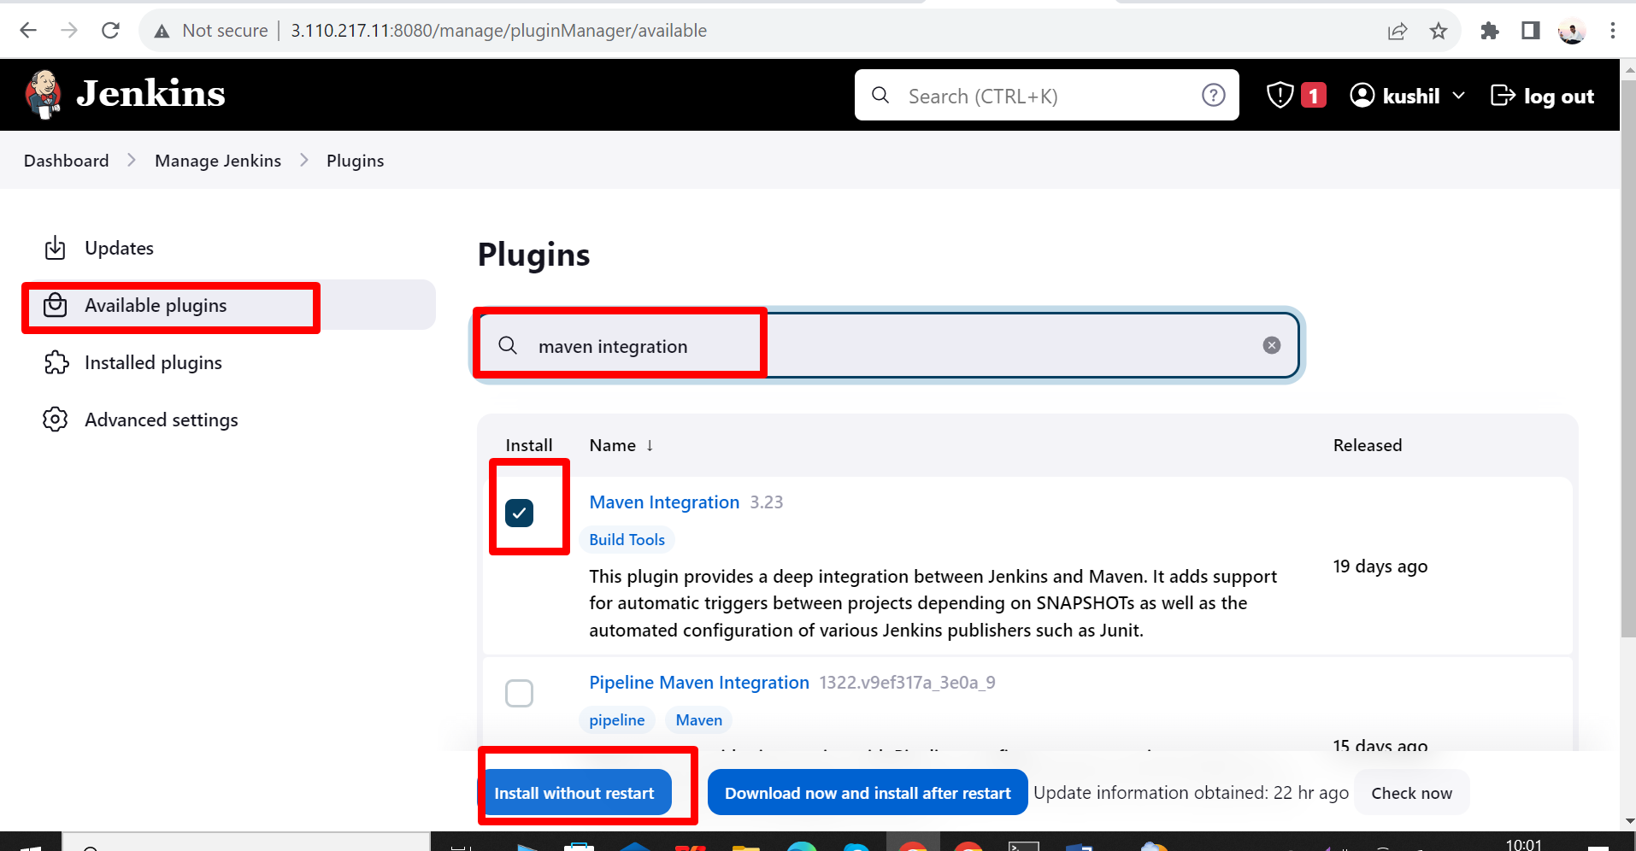

We installed maven integration successfully.

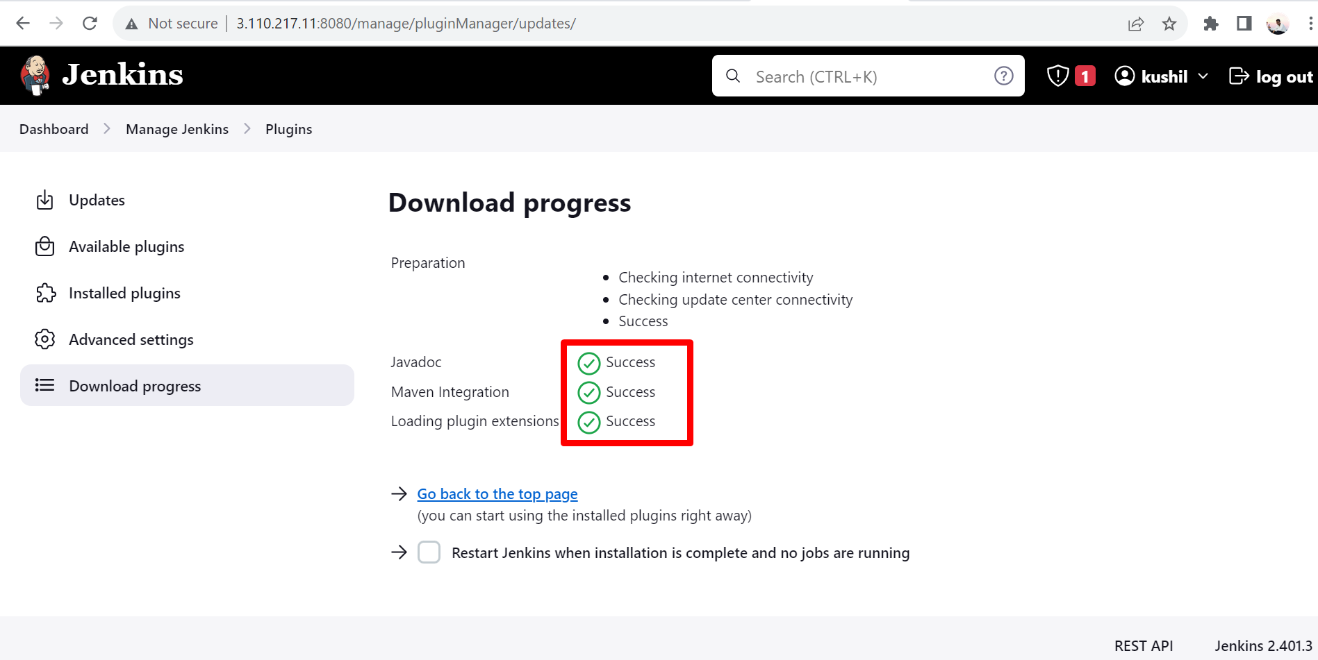

Step 2:- install maven on jenkins cli

Go to web browser and enter download maven .

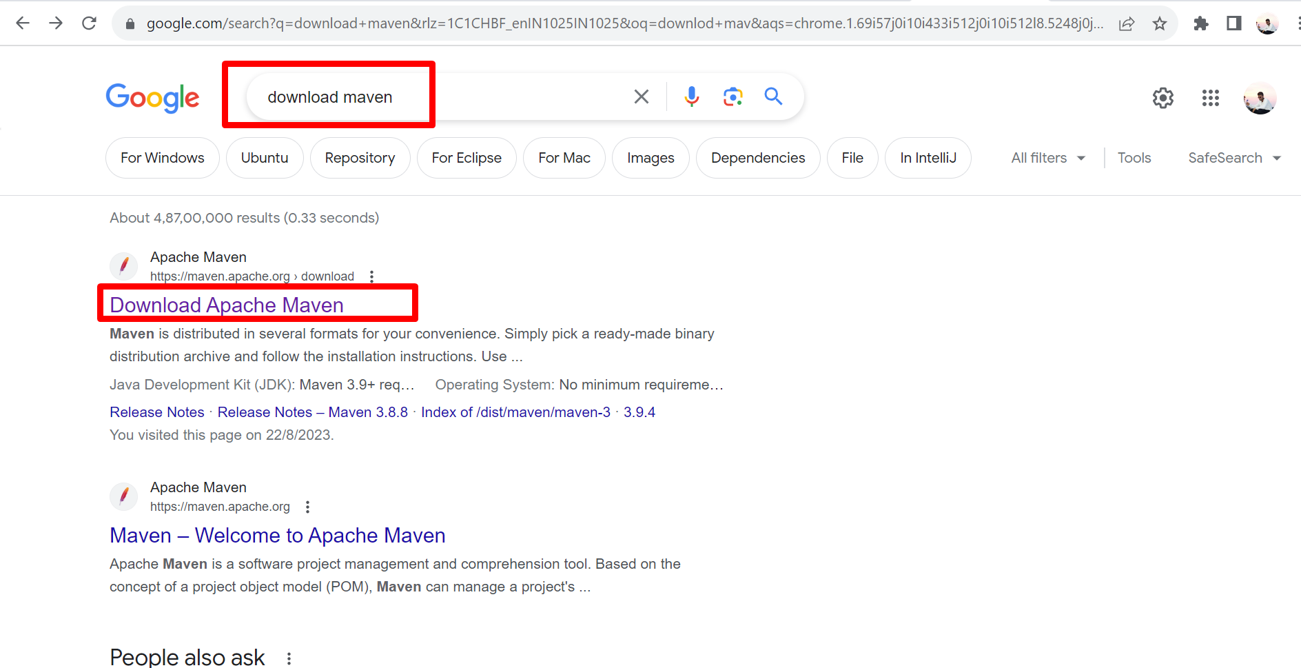

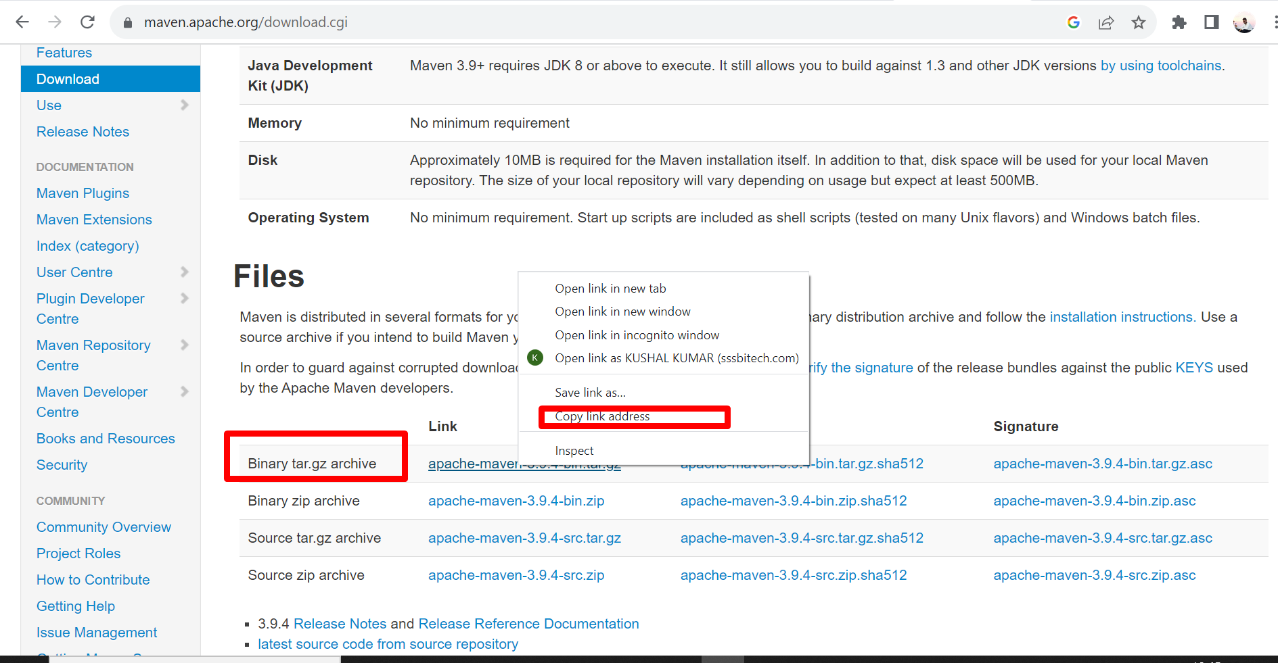

Copy the link address and paste in our server.

Note :- path = opt/



We successfully installed maven. 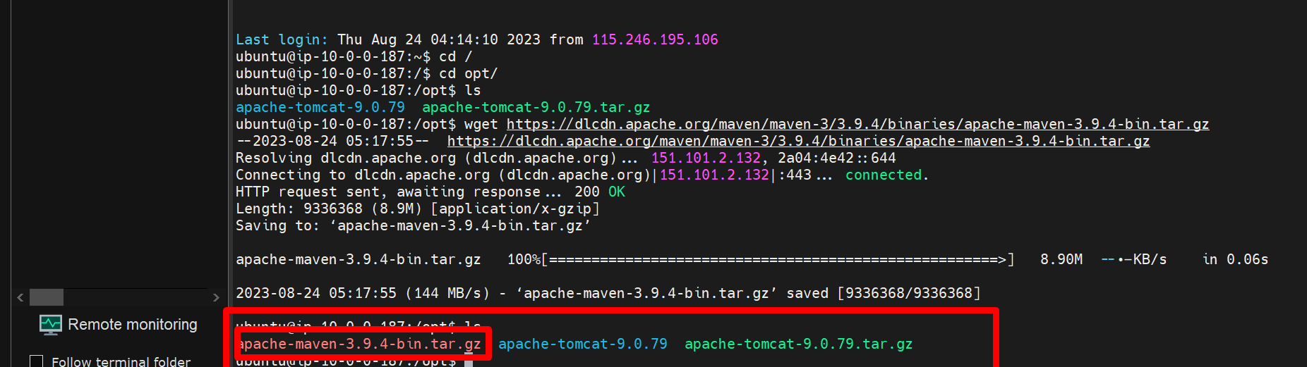

But this is zip file first we want to unzlip this file.

Using this comman:- **tar -xvf apache-maven-3.9.4-bin.tar.g**

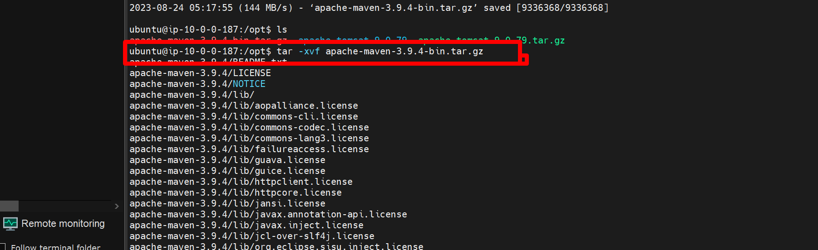

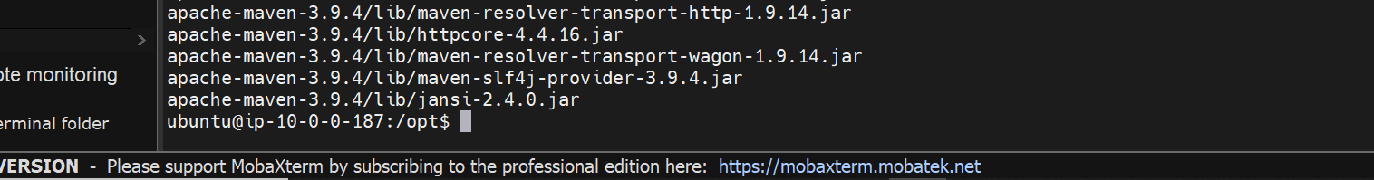

If you want to chane this **apache-maven-3.9.4** to **maven-3.9.**

Command**:- mv apache-maven-3.9.4 maven-3.9**

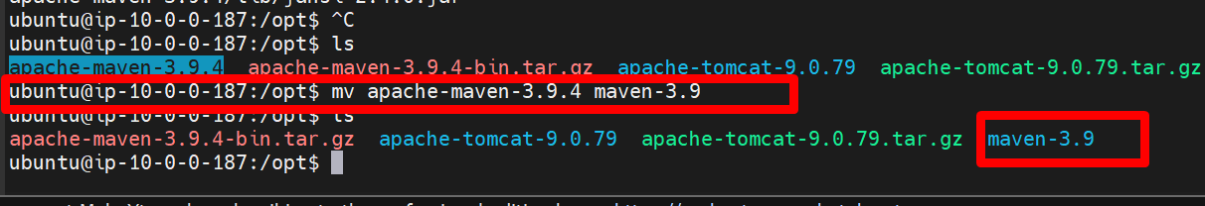

Now we want to see maven is installed or not .here maven is installed but mvn –version is not shown because we installed maven but we still not set path configuration.

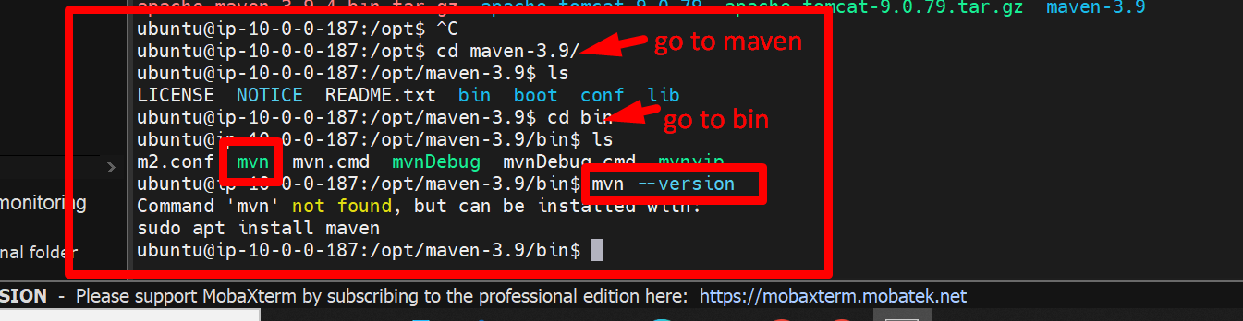

Next we set path configuration.

Edited file name = vi ~/.bash_profile



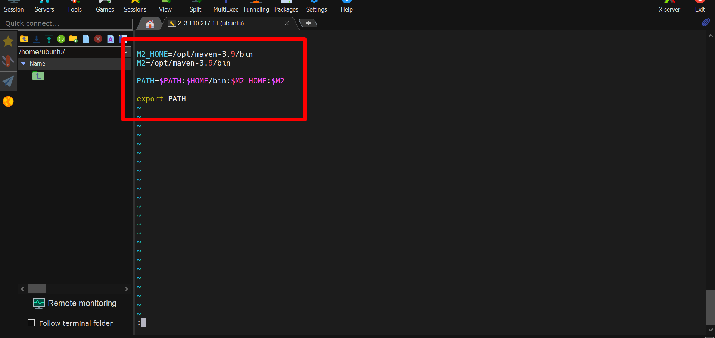

Next we want to echo that path

Must execute source ~/.bash_profile

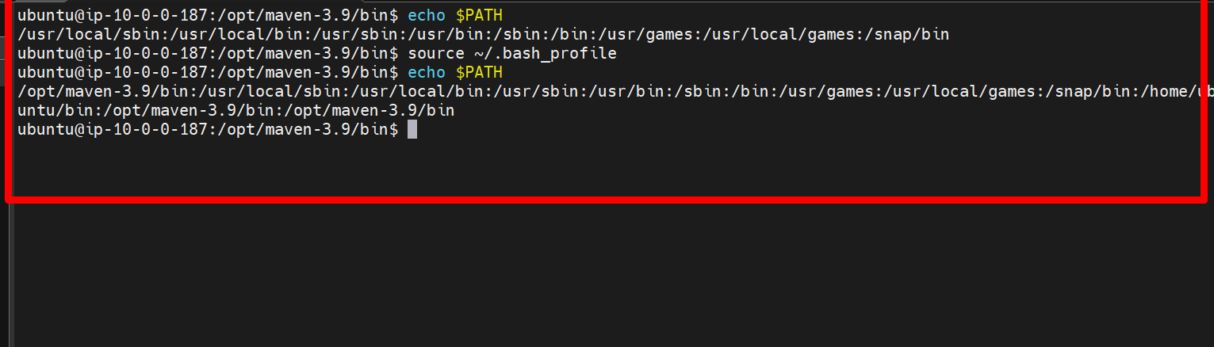

Next we check the version using command :- mvn –version

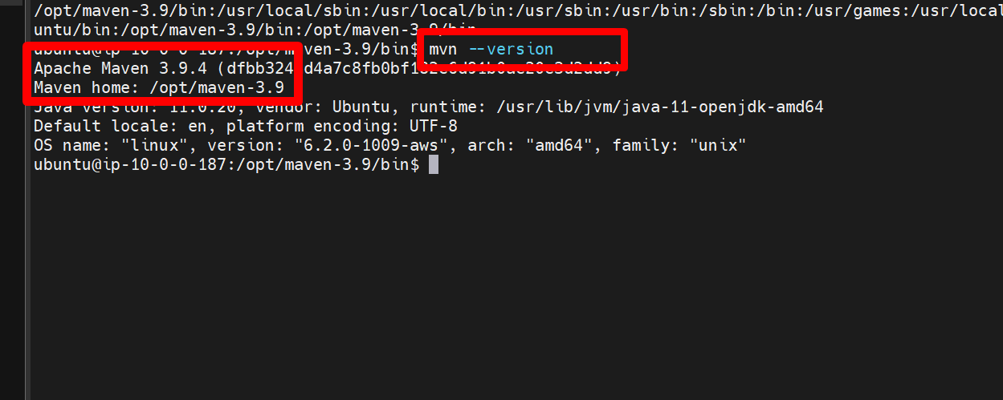

We successfully installed and set configuration maven in server.

Step 3:- Specify maven path in “ global tool configuration”

Go to jenkins

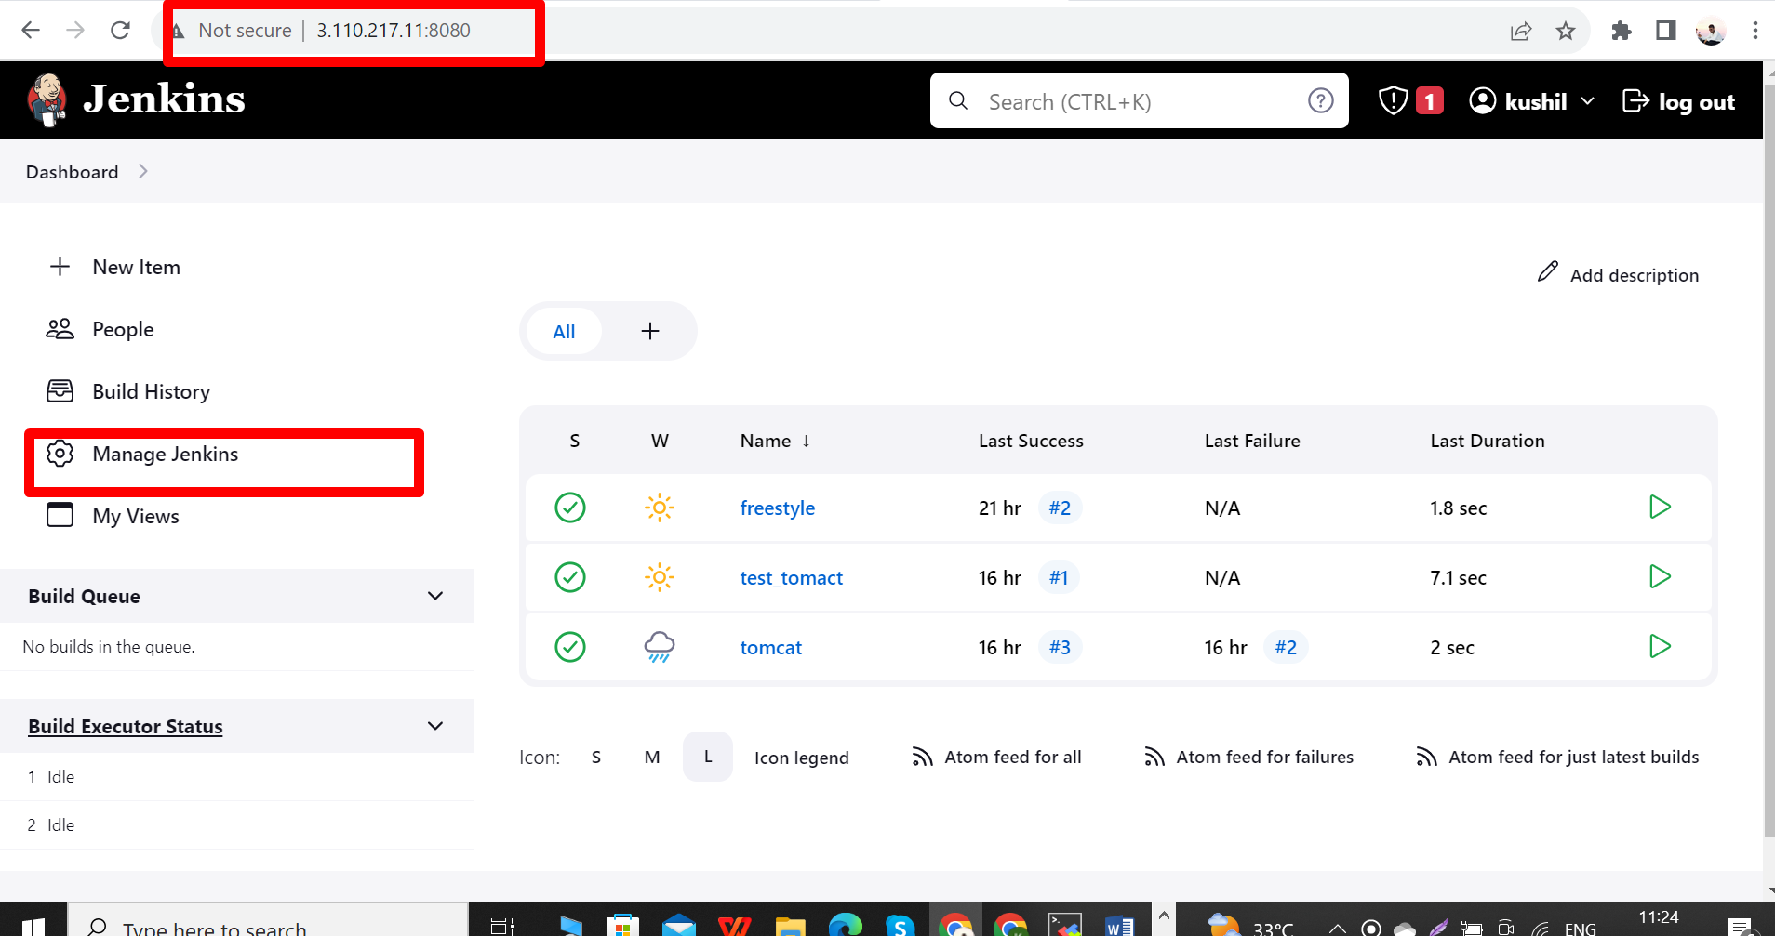

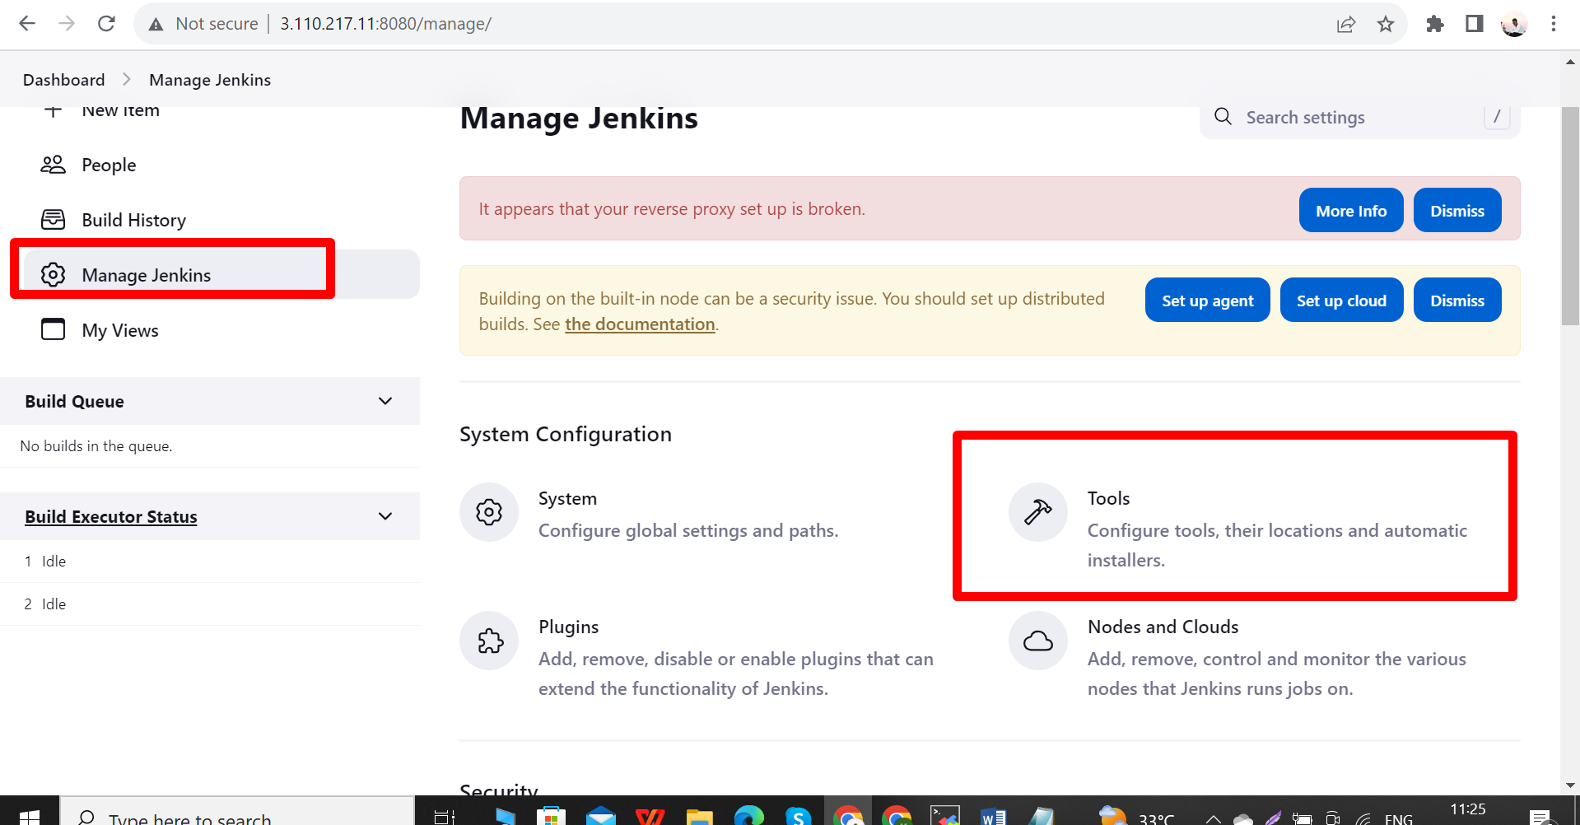

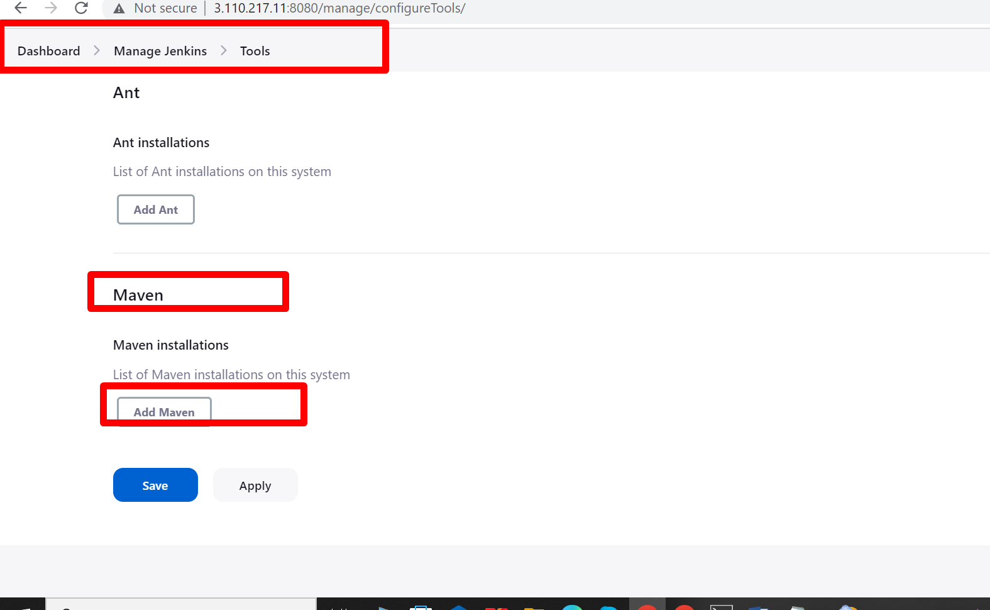

Here first we unselect this

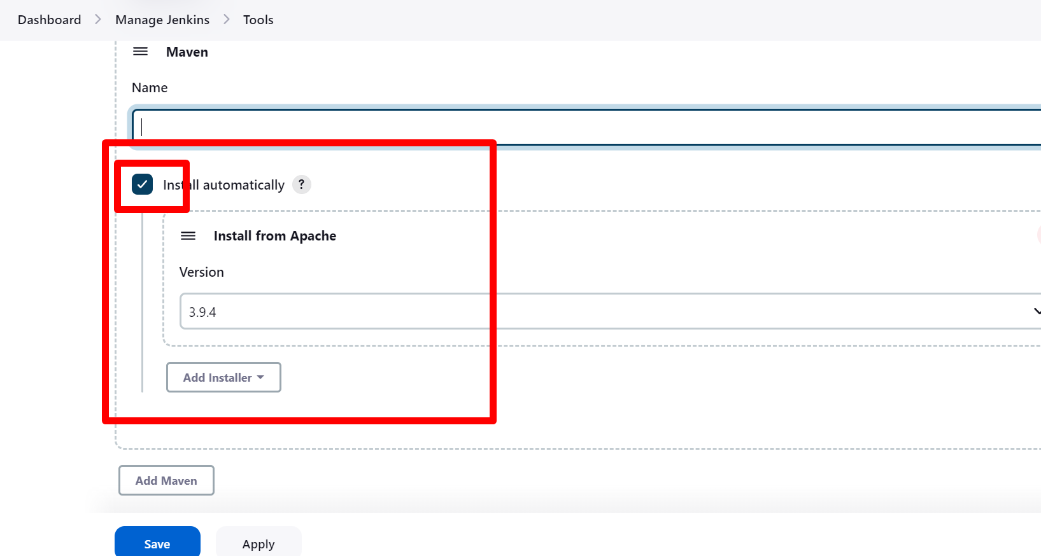

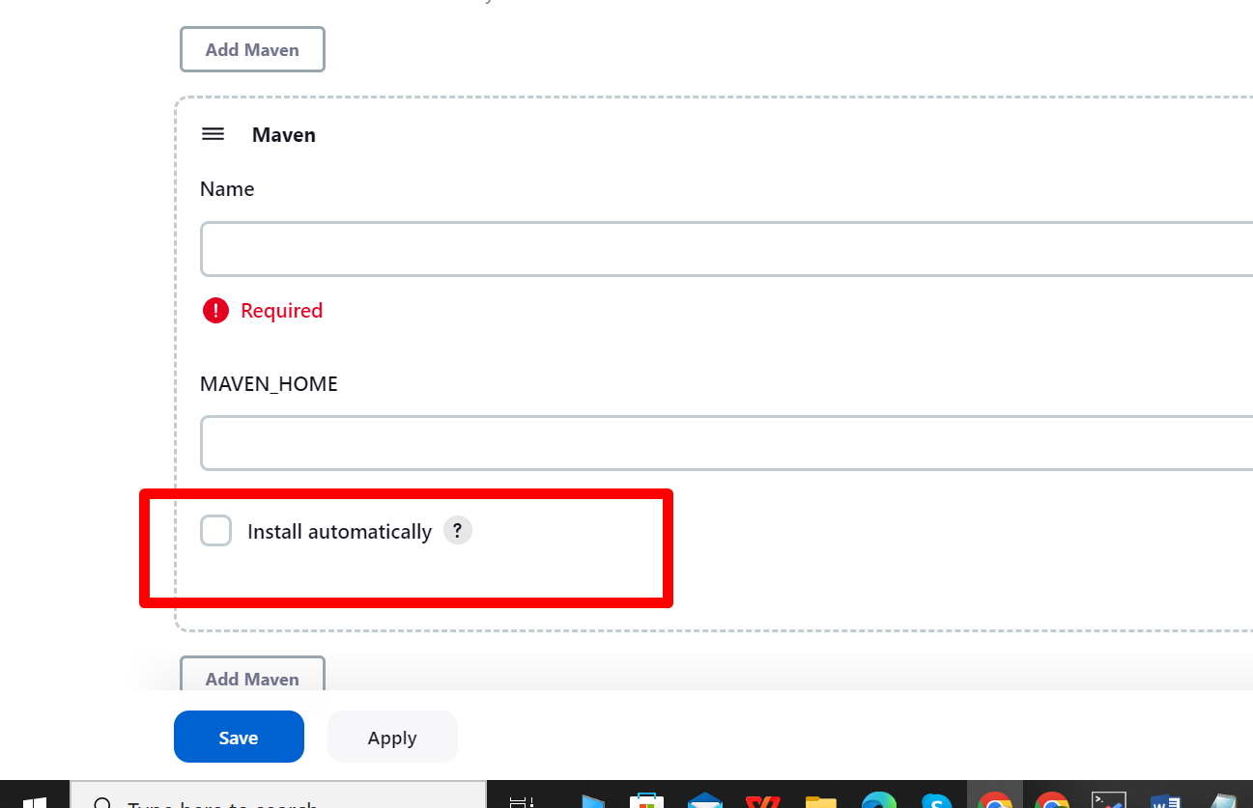

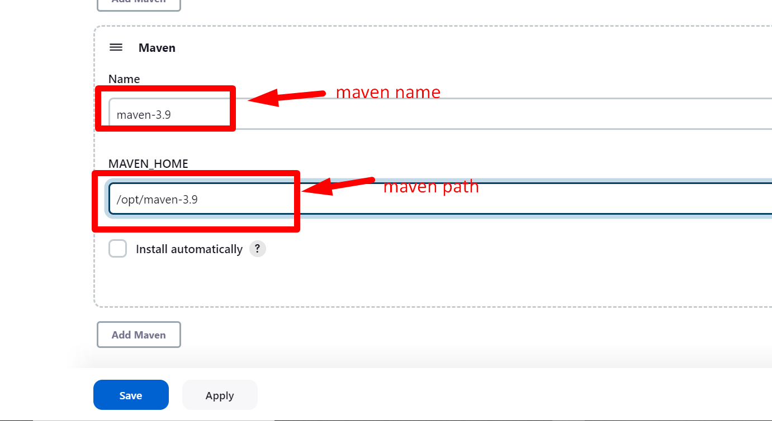

Step 4:- Specify java path in the “global tool configuration”.

Now also specify java path in the global too configuration.

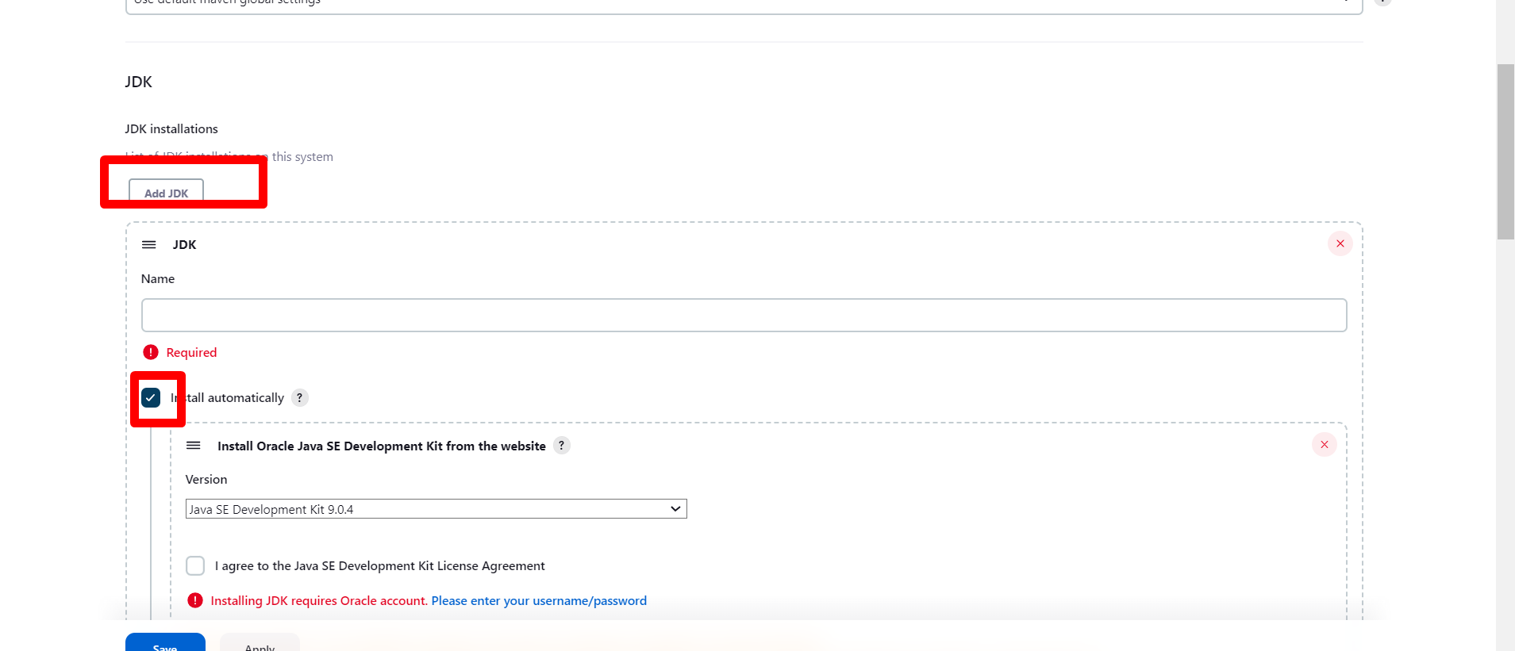

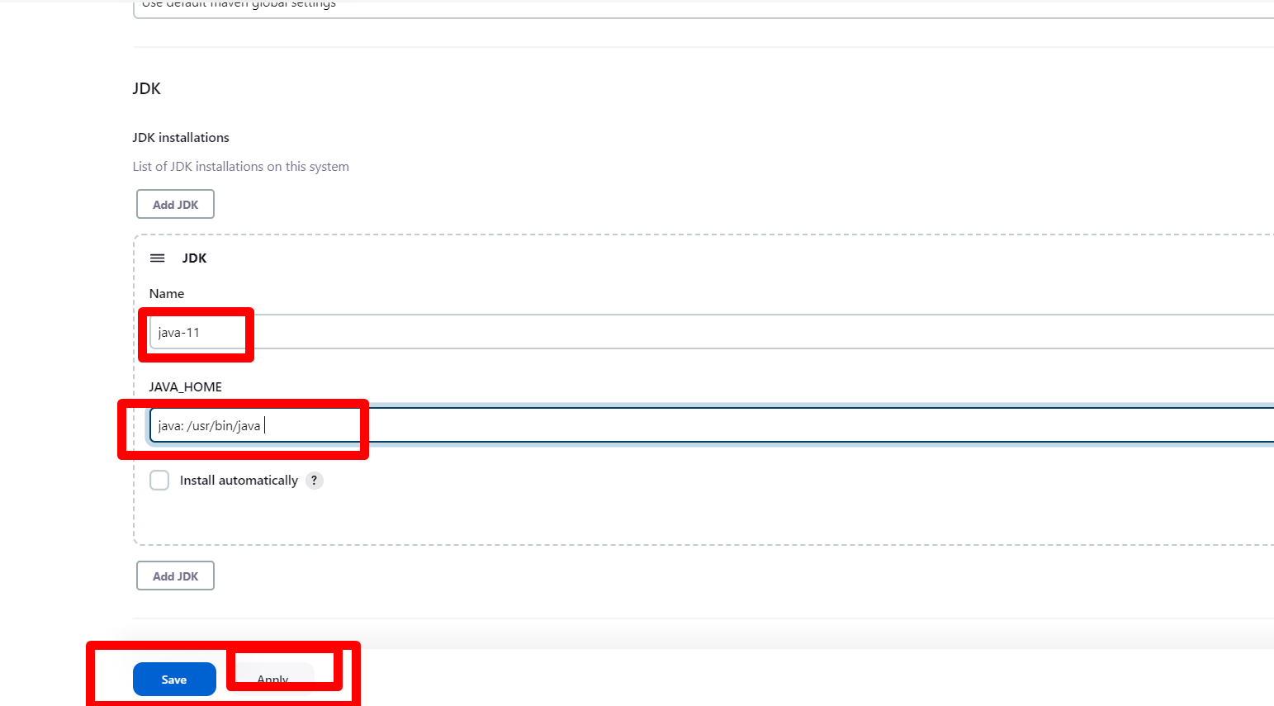

All are done now we want check maven is working or not.

Create new project in jenkins

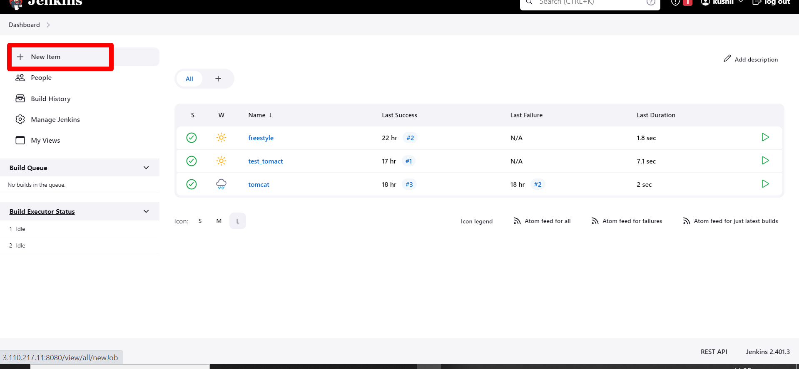

Enter name for that project then select pipeline and click OK.

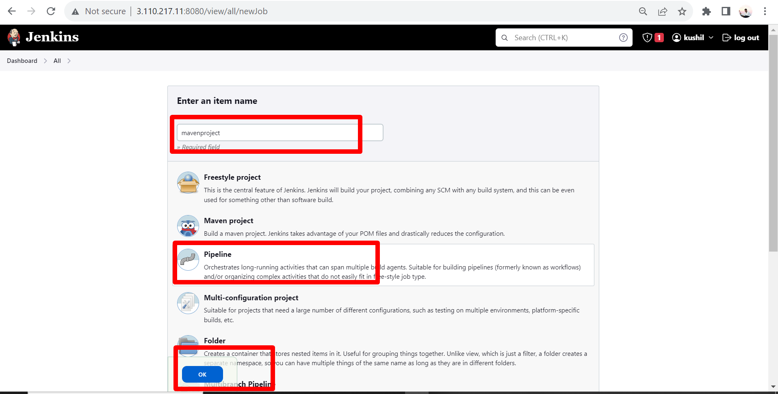

Now we want deploy the file from github

File name= king.txt

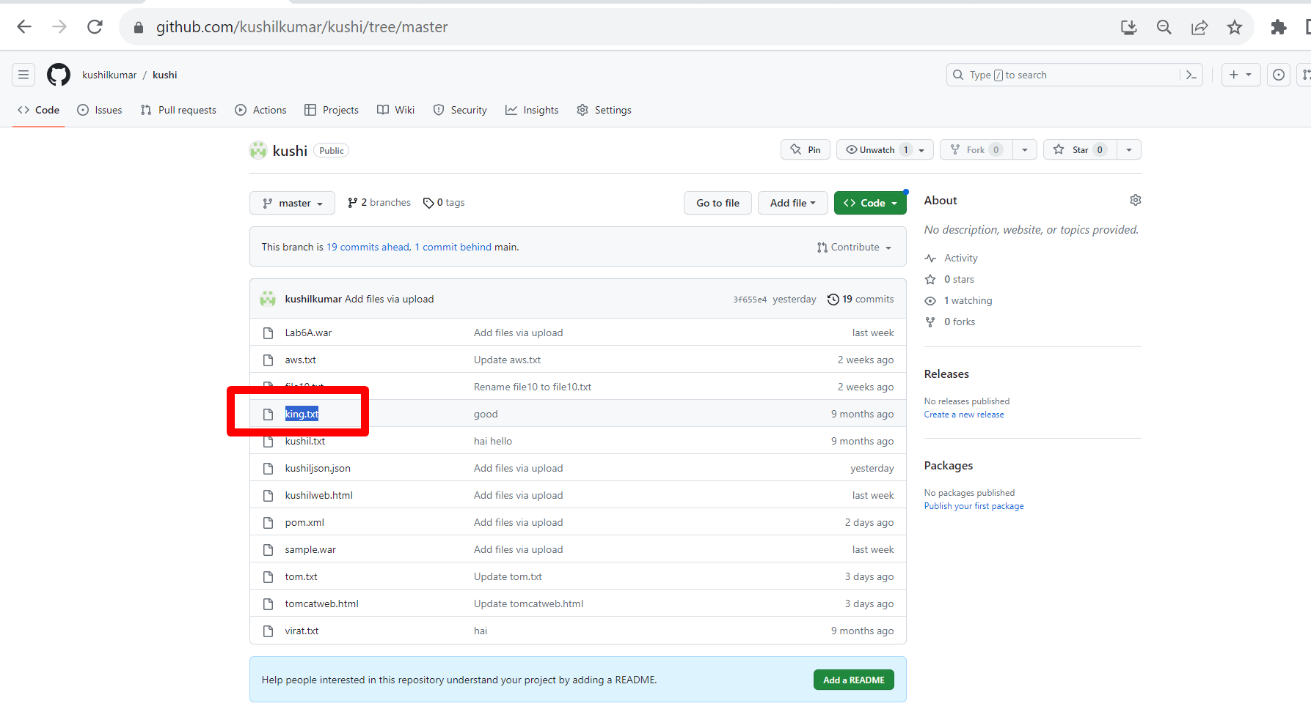

Now go to

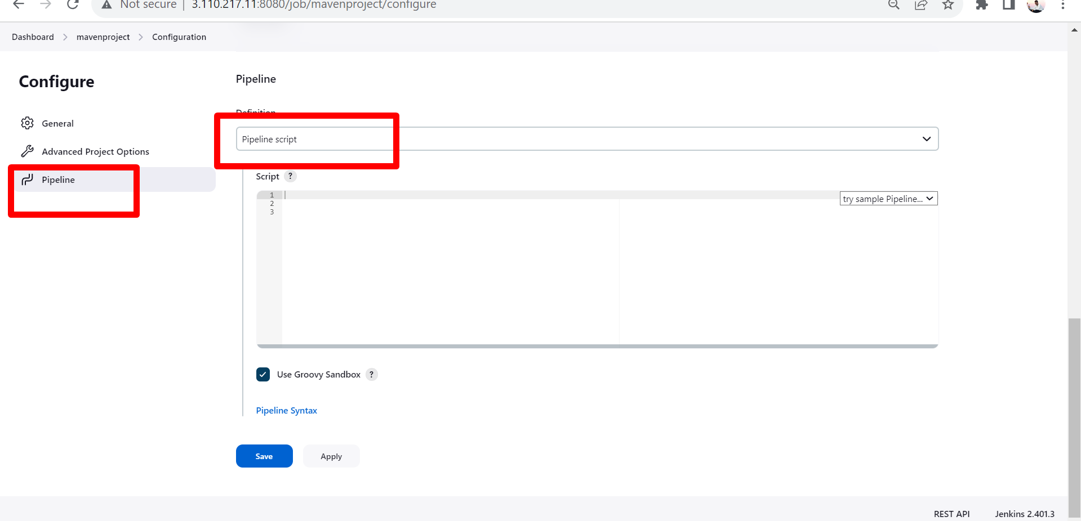

Now we add script to deploy file.

Script:-

pipeline {

agent any

environment {

PATH = " /opt/maven-3.9/bin:$PATH"

}

stages {

stage('Checkout') {

steps {

checkout([$class: 'GitSCM', branches: [[name: '*/master']], userRemoteConfigs: [[url: 'https://github.com/kushilkumar/kushi.git']]])

}

}

stage('Test') {

steps {

sh 'mvn test' // Run tests

}

}

stage('Build') {

steps {

sh 'mvn clean package' // Build your project

}

}

stage('Deploy') {

steps {

// Copy the built text file to Tomcat webapps directory

sh "cp king.txt /opt/apache-tomcat-9.0.79/webapps/ROOT"

}

}

}

}

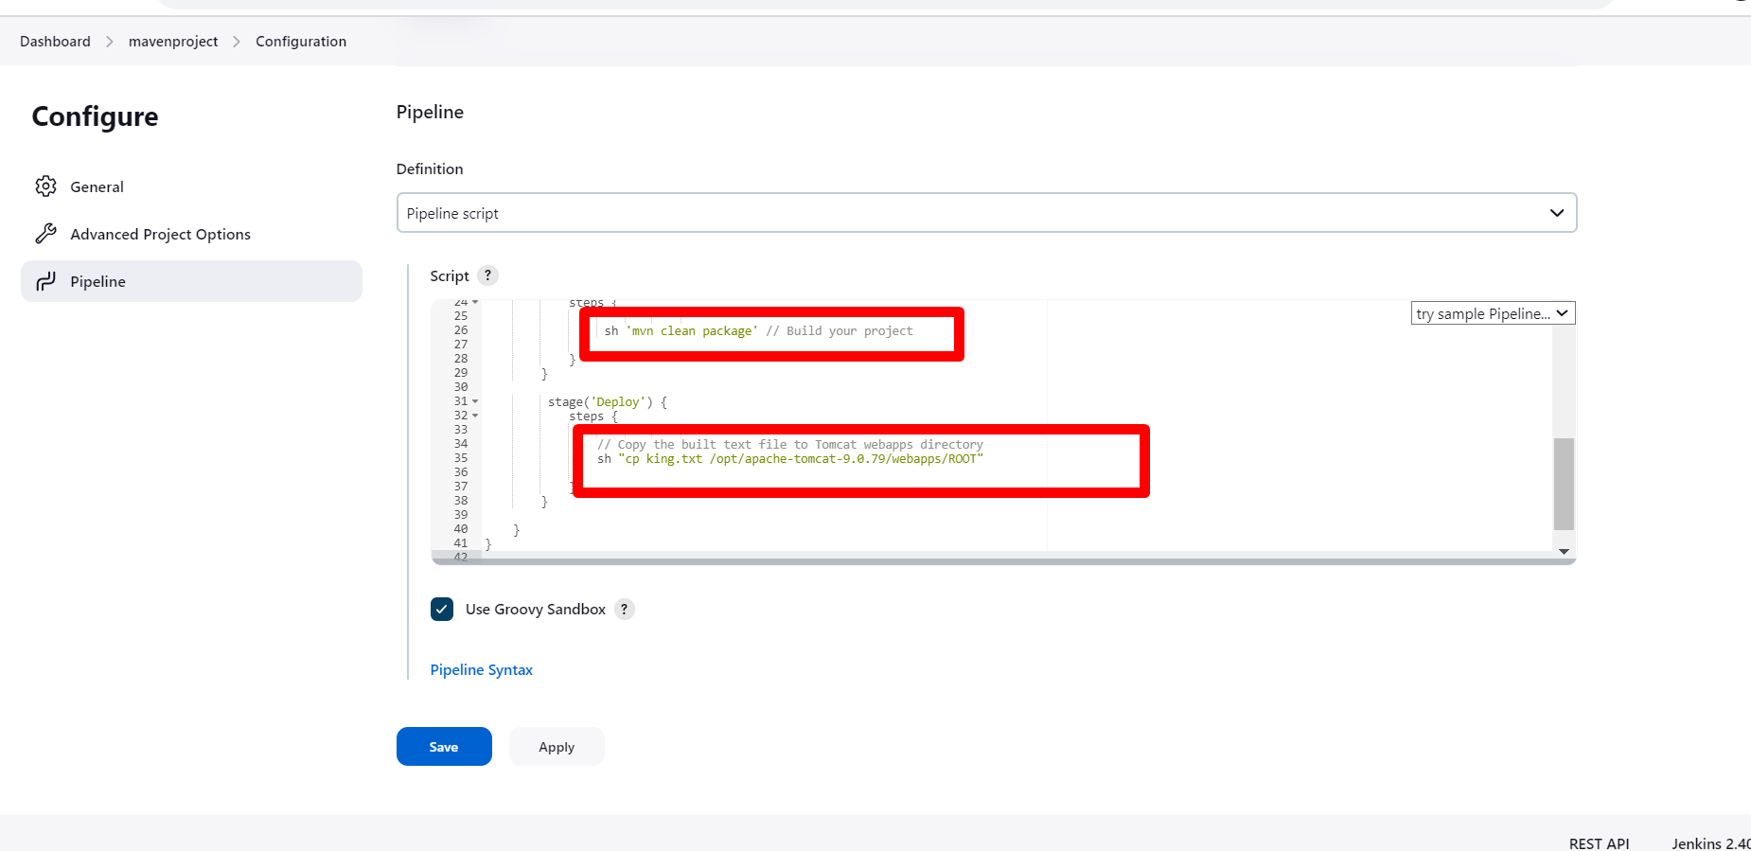

Next click **Apply** and **Save**.

Then click on build now.

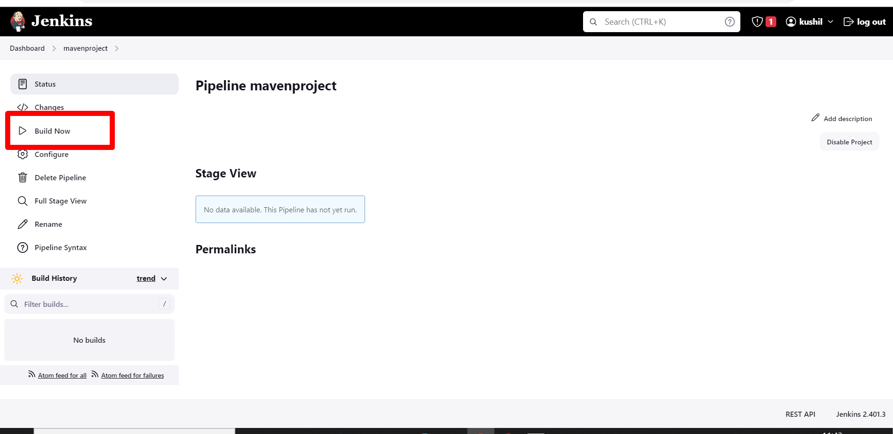

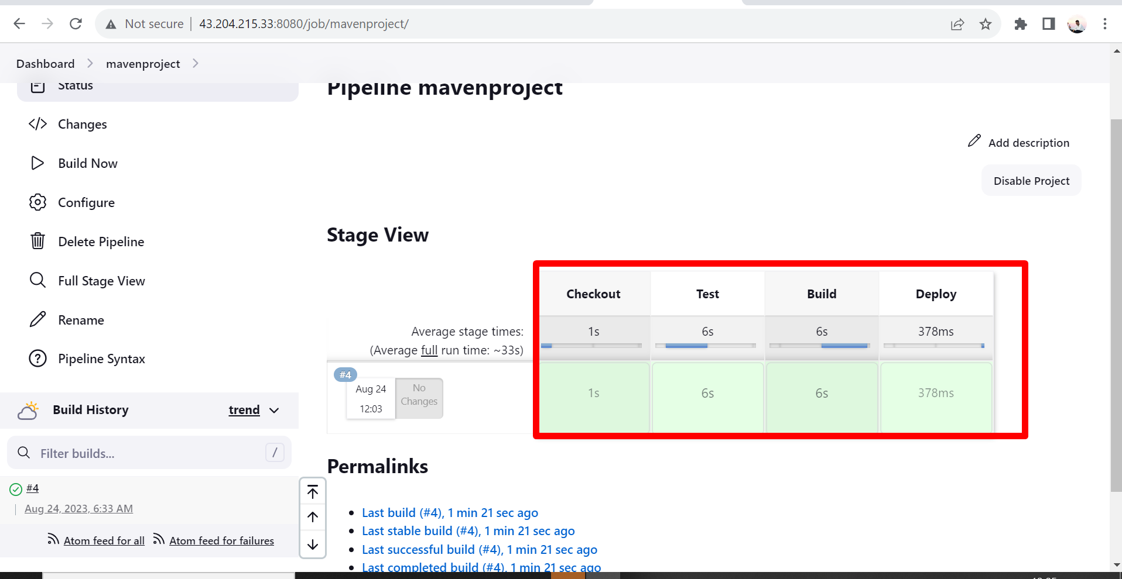

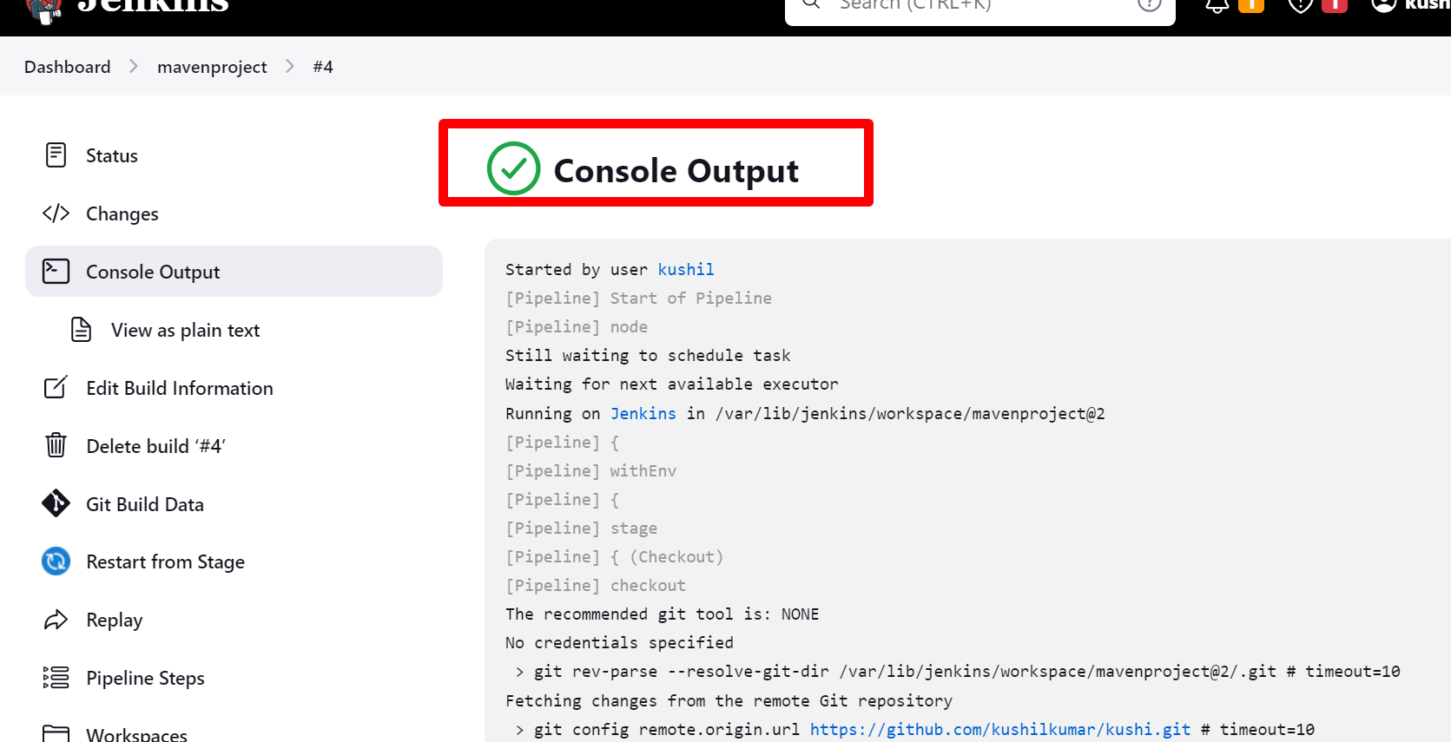

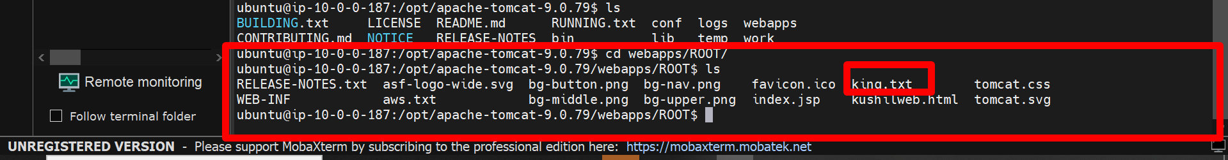

Now we want to see the output data in the tomcat web server

